PHASE II MAX FIRE BOX 3283KW

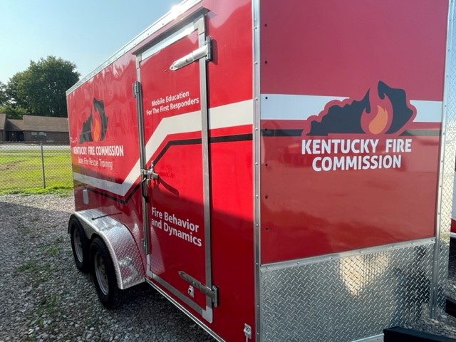

LOCATION

District 3 Training Center
Calhoun, KY

SPECIFICATIONS:

Length 12’
Width 7’
Mfg Date 2020
Tag-along 2 5/16” ball

OBJECTIVES

To carry the Phase II Max Fire Box to classes to educate the audience on Fire Behavior and Dynamics.

CAPABILITIES

This trailer contains the Phase II Prop, spare loads of burn materials and the items necessary to support this course. The trailer is equipped with a winch that aids in the loading and unloading process when remote classes are taught.

