HAZMAT TECHNICIAN TRAILER 2860KW
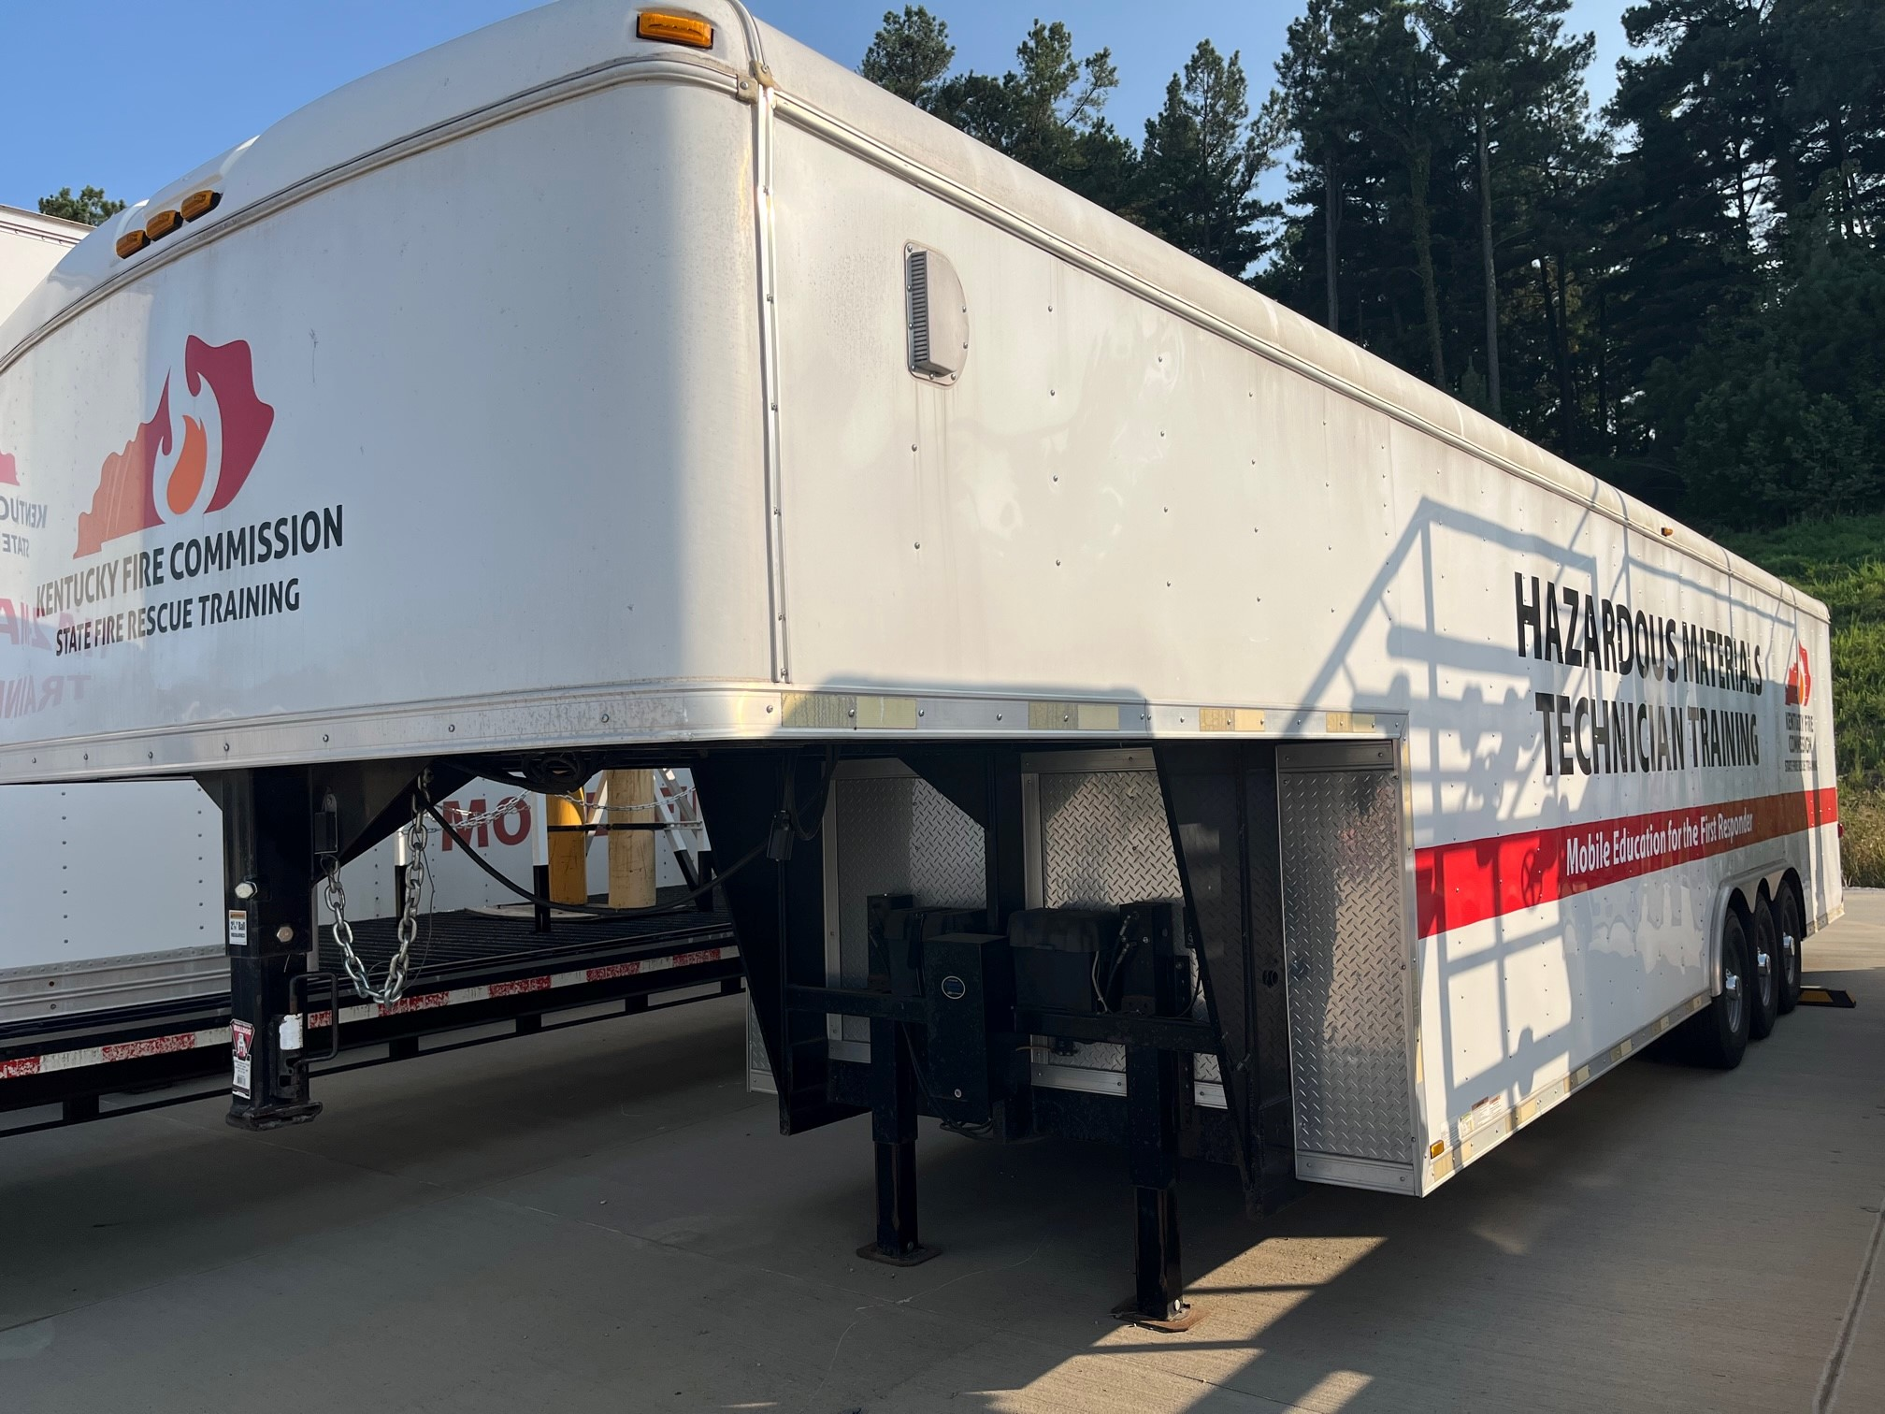

LOCATION

District 3 Training Center
Calhoun, KY

SPECIFICATIONS:

Length 36’
Width 8 ½’
Mfg date 2015
Gooseneck hitch

OBJECTIVES

This unit provides a couple of missions:
- Training of firefighters at the Operations level
- Training of firefighters at the Technician level

CAPABILITIES

The Hazmat Technician training trailer has several levels of protective suits to use during training as well as reference materials for Hazardous Materials. There are kits used to mitigate drum leaks, cylinder leaks up to and including railcar leaks. Overpack drums and sample drums with pre-established leaks are also on the trailer. This trailer is designed to teach Operations and Technician level Hazmat classes.

