FLATBED TRAILER K131667

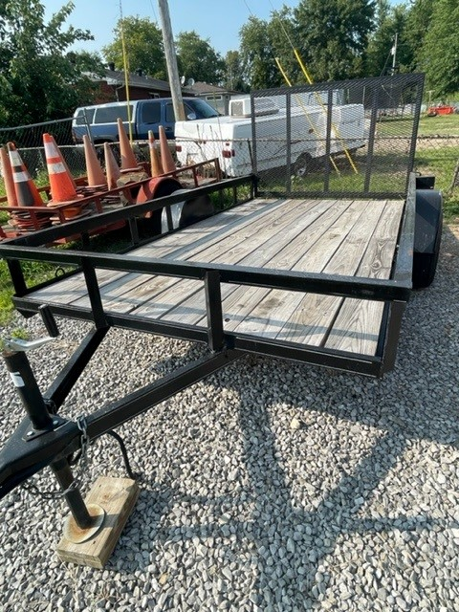

LOCATION

District 3 Training Center
Calhoun, KY

SPECIFICATIONS:

Length 12’
Width 7’
Mfg Date 2020
Tag-along 2 5/16” ball

OBJECTIVES

To carry light loads, lawn mowers, training props, etc…

CAPABILITIES

This trailer has a rear folding ramp door that allows for easy loading of the items needing to be carried on the trailer. This trailer is used routinely to move the gator, King Ceiling prop, lawn mower, and the funeral casket ramps.

