SAFETY HOUSE
(Safety House #2)

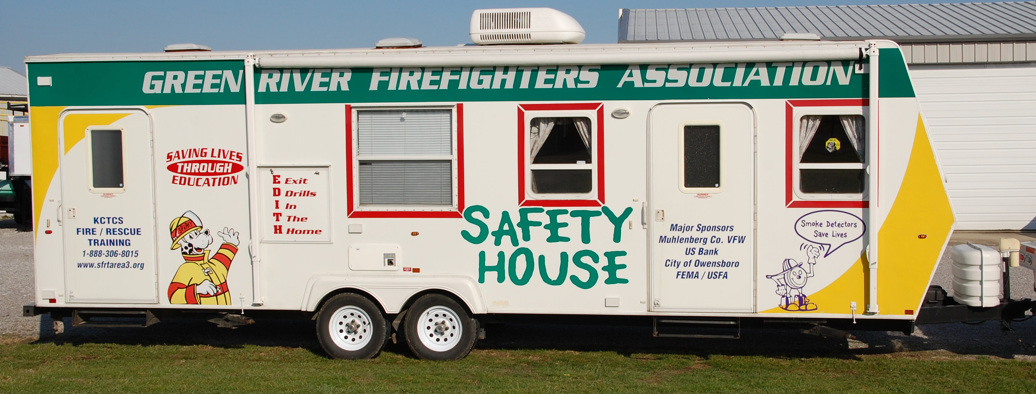
LOCATION:

Area 3 Training Center
Calhoun, KY

SPECIFICATIONS:

Length 32’
Width 8 ½’
Height 11”
Weight 6,480 lbs

OBJECTIVES:

Promote Home and Fire Safety education to people of all ages.

CAPABILITIES:

The Safety House #2 was built by Surrey Fire Safety in Ohio. This trailer has unique features that allow you to teach fire safety (as a child safety house) and also has a severe weather package. The fire safety package begins in the kitchen where you learn about typical emergencies that occur in the kitchen then you move the crowd into the living room. In the living room participants learn about safety such as cords, candles and fireplace emergencies as well as how to call 911. From here participants travel to the bedroom to learn about checking doors for heat, smoke detectors and EDITH. The trailer is equipped with a smoke machine to introduce smoke into the room and set the smoke detector off and allow the participants exit out the bedroom window.
The Severe Weather Package introduces the participants to procedures to follow if a severe weather warning is issued. The participants will watch the warning come across the television, they will hear the weather monitor alarm and issue the warning and then they will hear the severe storm come over the trailer along with the lightning and rumbling that is usually associated with severe storms.
There is a television and VCR mounted in an outside compartment where a safety message can be played to the group awaiting to go through the trailer. They may stand under the awning if the sun is shining or the rain is falling.
The trailer is equipped with a 5,000 watt generator to power the electronic equipment as well as the air conditioner. It also has a heater system to allow the trailer to be operated in all seasons.

